**PIZZA SALES SQL QUERIES**

**KPI**

1.Total Revenue:

select sum(total_price) as total_revenue from pizza_sales;

* 817860.0508384705

2.Average Order Value

select sum(total_price) /count(distinct order_id) as total_average_value from pizza_sales;

* 38.30726233435459

3.Total Pizza Sold

select sum(quantity) as total_pizza_sold from pizza_sales;

* 49574

4.Total Orders

select count(distinct order_id) as total_orders from pizza_sales;

* 21350

5.Average pizza per order

select cast(cast(sum(quantity) as decimal(10,2))/cast(count(distinct order_id)

as decimal(10,2)) as decimal(10,2)) as avg_pizza_per_order from pizza_sales;

* 2.32

1.Daily trend for total orders

select dayname(order_date) as order_day,count(distinct order_id) as total_orders

from pizza_sales group by dayname(order_date) order by total_orders desc;

Output:

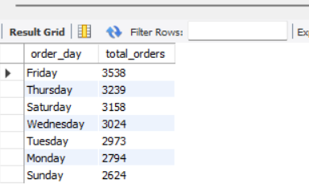

2.Hourly trend for orders

select hour(order_time) as order_hours,count(distinct order_id) as total_orders from pizza_sales

group by hour(order_time) order by total_orders ;

Output:

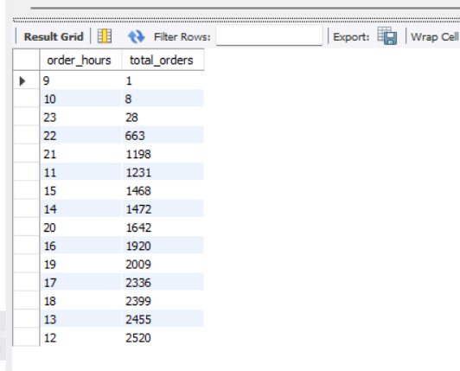

3.% of sales by pizza category

SELECT pizza_category, SUM(total_price) as total_revenue,cast(SUM(total_price) * 100 /

(SELECT SUM(total_price) FROM pizza_sales) as decimal(10,2)) as PCT

FROM pizza_sales

group by pizza_category

order by total_revenue desc;

Output:

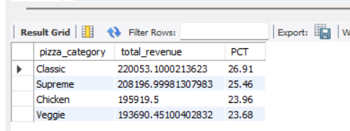

4. % of sales by pizza size

SELECT pizza_size, cast(SUM(total_price) as decimal(10,2))as total_revenue,cast(SUM(total_price) * 100 /

(SELECT SUM(total_price) FROM pizza_sales) as decimal(10,2)) as PCT

FROM pizza_sales

group by pizza_size

order by pizza_size;

Output:

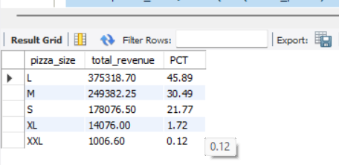

5. Total pizzas sold by pizza category

select pizza_category ,sum(quantity) as total_quantity_sold from pizza_sales group by pizza_category order by total_quantity_sold desc;

Output:

